Five-Year Buy-and-Track Market Project

Course: Essentials of Finance

Project Type: Group Project

Difficulty Level: Introductory

Project Purpose (Student-Friendly)
In this project, you will simulate investing $10,000 in several market securities five years ago.
This project is designed to help you:
- Understand how money grows (or declines) over time
- Compare stocks, stock funds, and bond funds
- Learn how market news impacts prices
You are not trading or changing investments. You are observing and analyzing.

Starting Assumptions (Very Important)
January 5, 2021 (first trading Tuesday of 2021), the following investments were made:
Investment | Ticker | Amount Invested
S&P 500 Index Fund | SPY | $10,000
Growth ETF #1 | QQQ | $10,000
Growth ETF #2 | VUG | $10,000
Core Bond ETF | AGG | $10,000
Individual Stock (Student-Specific) | Assigned | $10,000
✅ Each investment stands alone ✅ Total simulated investment per student: $50,000

Time Horizon
- Historical start date: January 5, 2021
- Tracking period: Entire semester
- End date: 04/23/26

Group Structure & Stock Assignment
- Each student selects one different U.S. stock
✅ No duplicate stocks

*Stock list will be provided.

Required Calculations (End of Semester)
For EACH investment, students will calculate:
1️⃣ Ending Value of the $10,000 investment 2️⃣ Dollar Gain or Loss 3️⃣ Total Percentage Return 4️⃣ Annualized Return (CAGR)

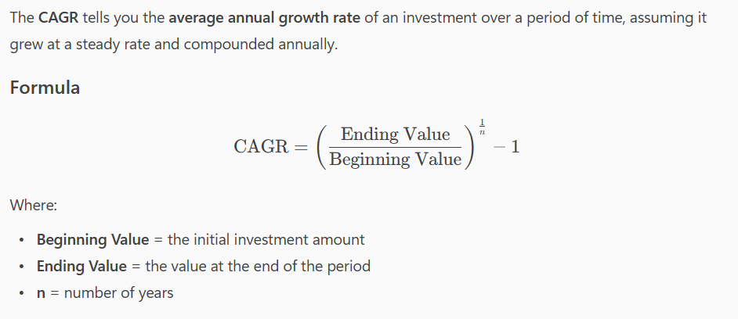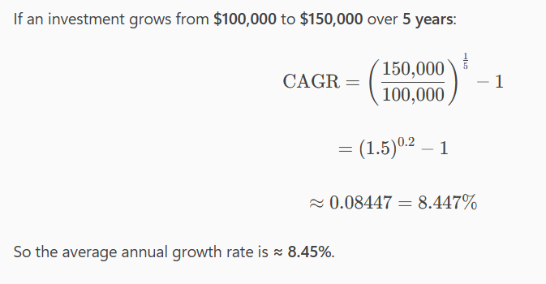

News & Market Events (Individual Work)
Each student selects three major news events related to:
- Their individual stock and
- The overall market (interest rates, inflation, Fed policy, recessions)
For each event:
- What happened?
- When did it occur?
- How did prices react around that time?
Length: ~½ page total (12-point font)

Reflection Questions (Group Submission)
Your group must answer the following:
- Which investment grew the most over five years?
- Which investment was the most stable?
- How did AGG behave when stocks were volatile?
- If this had been real money, what surprised you most?

Submission Requirements
✅ One Group PDF containing:
- Cover page
- Benchmark ETF results
- Individual stock pages (same format per student)
- News analysis
- Group reflection
- Charts and tables
✅ Excel tracking file uploaded separately (one per student).

PowerPoint presentations with your group’s findings will take place in the week of April 27. Your group will grade your participation, and class will grade your presentation, I will grade the rest.

Grading Emphasis
- Following directions (dates, amounts, format)
- Accuracy of calculations
- Clear explanations
- Proper organization

🚫 Common Mistakes to Avoid
❌ Changing the $10,000 amount ❌ Using non-Tuesday prices ❌ Day trading or switching investments ❌ Missing sections or reordering content

📌 Final Note to Students
This project is about learning how markets behave over time, not about picking “winner” stocks. Stay organized, track weekly, and ask questions early.

